**e.quinox Hydro Controller**

**Background Information on the Modular System**

**Ali Hadi Al-Hakim**

*The following is all designed for the Texas Instruments (TI) F28069 development board.*

For ease of development and circuit testing a modular approach to the Hydro Controller control board is being investigated. This approach turns each aspect of the control board into its own individual module. The advantage of this is each module should be much simpler to design, troubleshoot and, if necessary, to re-design.

The main aspect of this approach is that each module will use a common header template which will then allow stacking of modules in a variety of orders. The template is shown in Figure 1. Note that it has uniquely designed headers which have test pads on the edges, the expected header through-hole, and a via slot. The inclusion of a via is necessary for the cases that through-hole-plating is not available.

All of the headers on the template have a pitch of 2.54mm. This includes the "power towers" which have a 2x2 footprint simply to ensure that high currents may flow if necessary. They are asymmetrically placed to ensure there is only one possible orientation for the modules to be stacked.

Click on the links below to be taken to the modules currently expect to be designed. Note that the pin numbers are also shown and have been changed from those used in the original mono-board design.

Breakout Supply PWM and Measurement

Inverter Digital Output Digital Input

USB

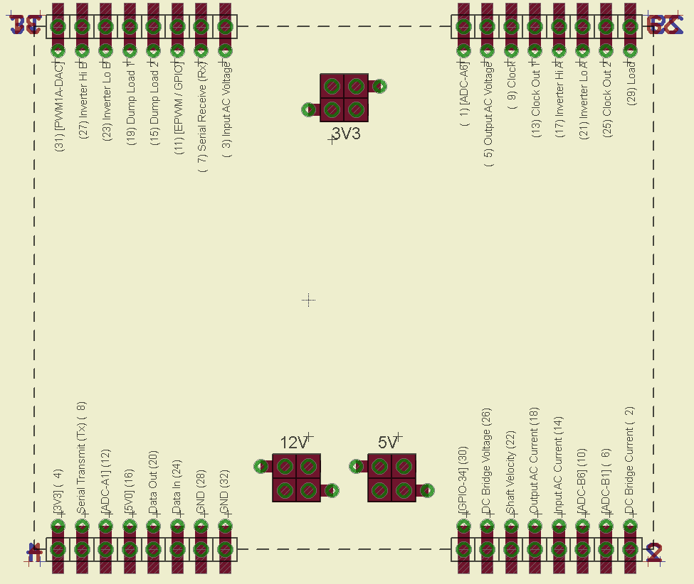

Figure 1: A screenshot of the stacking template footprint for the TI F28069 development board. The power towers are also included which will be supplied by a supply module and not the TI F28069.

A typical module should have the dimensions of:

W x H = 88.9mm x 63.5mm

The stack module template should be placed exactly at the coordinates:

( X , Y ) = ( 44.45mm x 31.75mm )

A module does not necessarily have to have these exact dimensions, but they are advised. Module matching is always guaranteed nonetheless by always using the identical template. The minimum possible module dimensions however are 81.92mm x 63.5mm.

**Modules**

**Breakout**

This is expected to always be the top module of the stack to accept the TI F28069 development board. It should simply break out all of the pins on the development board to match the stacking template. By doing this, all of the pins can far more easily be accessed for lower tolerance PCB manufacturing processes.

In addition to breaking out the pins of the development board, some LED signals should be included (i.e. power on, and a generic signal LED).

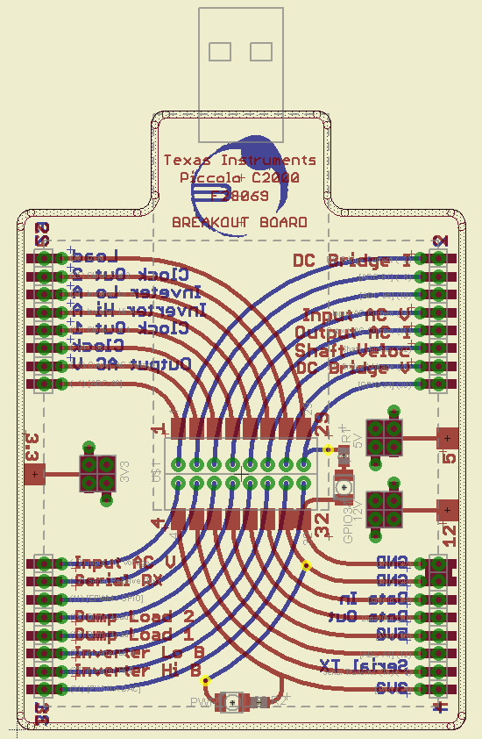

**Supply**

This module is designed as the base of the stack and where all of the power rails are generated from. All rails are regulated from a 12V supply which should is supplied to this module only. There are no connections of this module to the F28069 development board other than a connection to the ground pins.

LEDs should be included to clearly show whether or not a supply rail is successfully powered or not.

**Specification**

|  |  |  |
| --- | --- | --- |
| **Function** | **F28069 Pin** | **Input / Output** |
| 12V0 | n/a | Input / Output |
| Isolated 12V0 [x3] | n/a | Output |
| 5V0 | n/a | Output |
| 3V3 | n/a | Output |
| GND | 28, 32 | Input / Output |

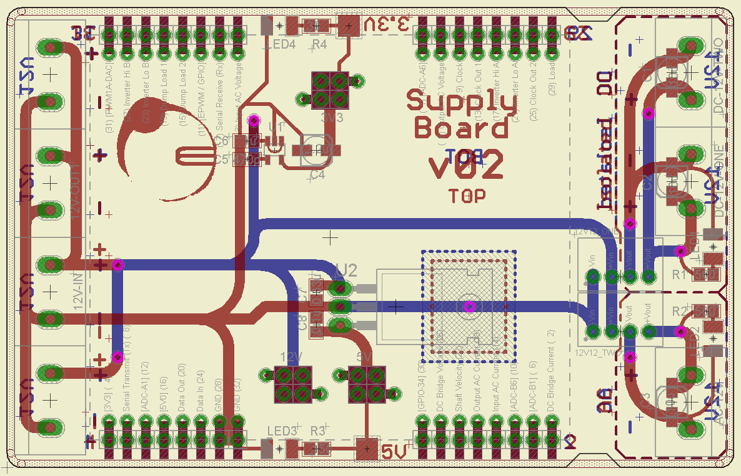

**PWM and Measurement**

This module is a simply input / output interfacing board. It needs to simply be designed to easily access some of the direct connection pins of the F28069 development board. For example, PWM outputs and ADC inputs can be directly connected to external PCBs to be used without many other components.

**Specification**

|  |  |  |
| --- | --- | --- |
| **Function** | **F28069 Pin** | **Input / Output** |
| Dump Load 1 (PWM) | 19 | Output |
| Dump Load 2 (PWM) | 15 | Output |
| GND | 28, 32 | Output |
|  |  |  |
| Shaft RPM (ADC) | 6 | Input |
| 12V (Supply) | n/a | Output |
| GND | 28, 32 | Output |
|  |  |  |
| AC Input Current (ADC) | 14 | Input |
| AC Input Voltage (ADC) | 3 | Input |
| DC Bridge Current (ADC) | 26 | Input |
| DC Bridge Voltage (ADC) | 2 | Input |
| GND | 28, 32 | Output |

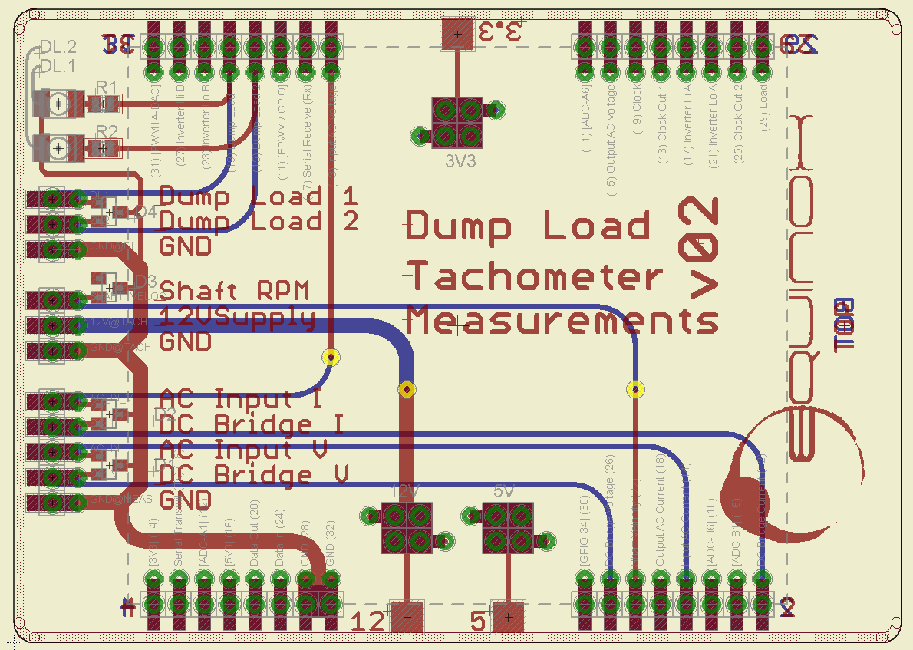

**Inverter**

This module should be another simply one similar to the PWM and Measurement module. It again will consist mostly of direct connection inputs and outputs from the F28069 development board.

**Specification**

|  |  |  |
| --- | --- | --- |
| **Function** | **F28069 Pin** | **Input / Output** |
| Phase A High (PWM) | 17 | Output |
| Phase A Low (PWM) | 21 | Output |
| Phase B High (PWM) | 27 | Output |
| Phase B Low (PWM) | 23 | Output |
| AC Output Voltage (ADC) | 5 | Input |
| AC Output Current (ADC) | 18 | Input |
| Signal LED (GPIO) | 11 | Output |
| GND | 28, 32 | Output |
|  |  |  |
| Shutdown | From Digital Out module | Output |

Not yet designed

**Digital Output**

This module is one of the more complicated ones but should be possible to squeeze onto a single module. It is one of the most important modules as it outputs safety signals, transmits data to the LCD screen and toggles activity LEDs. As a result there will be multiple output pins from this board, although through shift registers and not directly connected to the F28069 development board.

**Specification**

|  |  |  |
| --- | --- | --- |
| **Function** | **F28069 Pin** | **Input / Output** |
| Clock (GPIO) | 9 | Output |
| Clock Out 1 (GPIO) | 13 | Output |
| Clock Out 2 (GPIO) | 25 | Output |
| Data Out (GPIO) | 20 | Output |
| 3V3 (Supply) | n/a | Output |
| GND | 28, 32 | Output |
|  |  |  |
| **Function** | **Shift Register (SN74AHC595) Pin** | **Input / Output** |
| Start-up | SR1: QA | Output |
| LCD D0 | SR1: QB | Output |
| LCD D1 | SR1: QC | Output |
| LCD D2 | SR1: QD | Output |
| LCD D3 | SR1: QE | Output |
| LCD Reset | SR1: QF | Output |
| LCD F | SR1: QG | Output |
| Unused Output | SR1: QH |  |
|  |  |  |
| Protection PCB Trigger | SR2: QA | Output |
| Shutdown | SR2: QB | Output |
| Control LED (Red) | SR2: QC | Output |
| Control LED (Green) | SR2: QD | Output |
| Dump Load 1 LED | SR2: QE | Output |
| Dump Load 2 LED | SR2: QF | Output |
| Inverter LED | SR2: QG | Output |
| Update LED | SR2: QH | Output |

v01 Designed

**Digital Input**

This is another important module which is required to allow user control of the control system and monitoring. The primary use of this module is to receive button press data and the update the LCD screen as a result. Thus, this module is the main way for a user to interface with the Hydro Controller. Additionally, this module is very important to receive fault data from the protection PCB to initiate an emergency shutdown.

**Specification**

|  |  |  |
| --- | --- | --- |
| **Function** | **F28069 Pin** | **Input / Output** |
| Clock (GPIO) | 9 | Output |
| Load (GPIO) | 29 | Output |
| Data In (GPIO) | 24 | Input |
| 3V3 (Supply) | n/a | Output |
| GND | 28, 32 | Output |
|  |  |  |
| **Function** | **Shift Register (74HCT165) Pin** | **Input / Output** |
| Protection PCB Fault | D0 | Input |
| Button (Down) | D1 | Input |
| Button (Left) | D2 | Input |
| Button (Up) | D3 | Input |
| Button (Right) | D4 | Input |
| Unused In | D5 | Input |
| Unused In | D6 | Input |
| Unused In | D7 | Input |

v01 Designed

**USB**

This module will specifically allow interfacing with the control stack via USB to a computer. This should allow data read by the control board to be transmitted to a PC and possibly even allow some control from a PC. It should be a relatively simple module to design. However, it is not a particularly important module for the time being.

**Specification**

|  |  |  |
| --- | --- | --- |
| **Function** | **F28069 Pin** | **Input / Output** |
| Transmit bit Tx (GPIO) | 8 | Output |
| Receive bit Rx (GPIO) | 7 | Output |
| 3V3 (Supply) | n/a | Output |
| GND | 28, 32 | Output |
|  |  |  |
| USB Data 1 | n/a | Output |
| USB Data 2 | n/a | Output |
| 5V0 (Supply) | n/a | Output |

Not yet designed